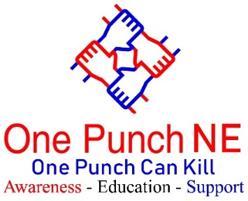

3 Birchington Ave
South Shields
NE33 4TY
 | RELEASE DATE  December 4, 2020
  Contact | Maxine Thompson-Curl
  Telephone | 07950421183
  Email | northeast@onepunch.org.uk
  Website  Twitter  FaceBook | www.onepunch.org.uk  www.twitter.com/OnePunchNE  www.facebook.com/OnePunchNE

Punched Out Cold 2020
Start
Media Interviews Friday 4th December 11am – 12:15
PLEASE NOTE interviews will take place at Durham Constabulary, Police Headquarters, Aykley Heads, Durham, DH1 5TT
Available for interviews: Maxine Thompson-Curl CEO One Punch UK, Chief Constable Jo Farrell Durham Police
Durham PCVC’s office
(others may become available)

As the Christmas party season approaches, One Punch UK launches its 2020 Punched Out Cold campaign - now in its 7th Year.
The campaign aims to raise awareness of the devastation one punch can cause, and urges people to think about the long-term consequences of their actions.
One Punch UK hopes to get every police force in the UK supporting the campaign so the hard-hitting poster and important message reaches as many people as possible. In 2019, the poster was viewed more than 2.1 million times on social media, something the campaign hopes to double this year.
All three regional police forces and their PCCs, (Durham, Northumbria, Cleveland) firmly believes that education is key.
Please inform us if you are attending info@onepunch.org.uk and we will try to accommodate you best we can.
Ends

